SQLite practice

Creating a dataset

create table test_data (
class VARCHAR(5),
age integer,
menopause VARCHAR(20),
tumor_size integer,
node_caps VARCHAR(5),
deg_malig integer,
breast VARCHAR(20),
breast_quad VARCHAR(20),
irradiat VARCHAR(20));

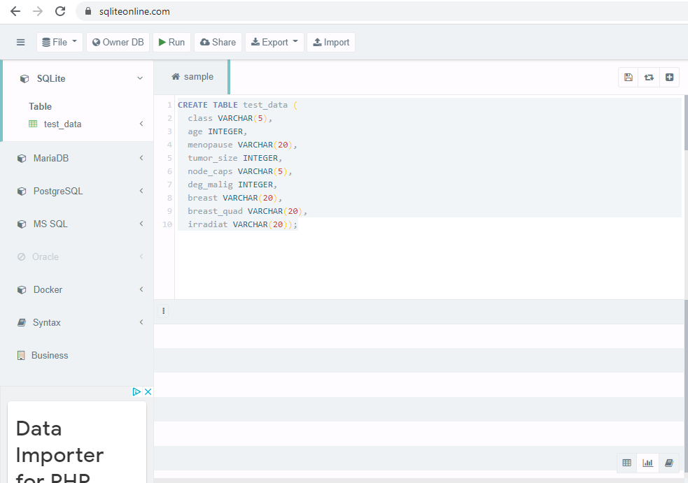

INSERT INTO test_data (class, age, menopause, tumor_size, node_caps, deg_malig, breast, breast_quad, irradiat) VALUES ('NO', 35, 'premeno', 31, 'no', 3,'left', 'left_low', 'no');
INSERT INTO test_data (class, age, menopause, tumor_size, node_caps, deg_malig, breast, breast_quad, irradiat) VALUES ('NO', 42, 'premeno', 22, 'no', 2,'right', 'right_up', 'no');
INSERT INTO test_data (class, age, menopause, tumor_size, node_caps, deg_malig, breast, breast_quad, irradiat) VALUES ('NO', 30, 'premeno', 23, 'no', 2,'left', 'left_low', 'no');
INSERT INTO test_data (class, age, menopause, tumor_size, node_caps, deg_malig, breast, breast_quad, irradiat) VALUES ('NO', 61, 'ge40', 16, 'no', 2,'right', 'left_up', 'no');
INSERT INTO test_data (class, age, menopause, tumor_size, node_caps, deg_malig, breast, breast_quad, irradiat) VALUES ('NO', 45, 'premeno', 2, 'no', 2,'right', 'right_low', 'no');
INSERT INTO test_data (class, age, menopause, tumor_size, node_caps, deg_malig, breast, breast_quad, irradiat) VALUES ('NO', 64, 'ge40', 17, 'no', 2,'left', 'left_low', 'no');
INSERT INTO test_data (class, age, menopause, tumor_size, node_caps, deg_malig, breast, breast_quad, irradiat) VALUES ('NO', 52, 'premeno', 27, 'no', 2,'left', 'left_low', 'no');
INSERT INTO test_data (class, age, menopause, tumor_size, node_caps, deg_malig, breast, breast_quad, irradiat) VALUES ('NO', 67, 'ge40', 21, 'no', 1,'left', 'left_low', 'no');
INSERT INTO test_data (class, age, menopause, tumor_size, node_caps, deg_malig, breast, breast_quad, irradiat) VALUES ('YES', 41, 'premeno', 52, 'no', 2,'left', 'left_low', 'no');
INSERT INTO test_data (class, age, menopause, tumor_size, node_caps, deg_malig, breast, breast_quad, irradiat) VALUES ('YES', 43, 'premeno', 22, 'no', 2,'right', 'left_up', 'no');
INSERT INTO test_data (class, age, menopause, tumor_size, node_caps, deg_malig, breast, breast_quad, irradiat) VALUES ('YES', 41, 'premeno', 1, 'no', 3,'left', 'central', 'no');
INSERT INTO test_data (class, age, menopause, tumor_size, node_caps, deg_malig, breast, breast_quad, irradiat) VALUES ('YES', 44, 'ge40', 27, 'no', 2,'left', 'left_low', 'no');
INSERT INTO test_data (class, age, menopause, tumor_size, node_caps, deg_malig, breast, breast_quad, irradiat) VALUES ('YES', 61, 'lt40', 14, 'no', 1,'left', 'right_up', 'no');
INSERT INTO test_data (class, age, menopause, tumor_size, node_caps, deg_malig, breast, breast_quad, irradiat) VALUES ('YES', 55, 'ge40', 26, 'no', 3,'left', 'right_up', 'no');
INSERT INTO test_data (class, age, menopause, tumor_size, node_caps, deg_malig, breast, breast_quad, irradiat) VALUES ('YES', 44, 'premeno', 32, 'no', 3,'left', 'left_up', 'no');

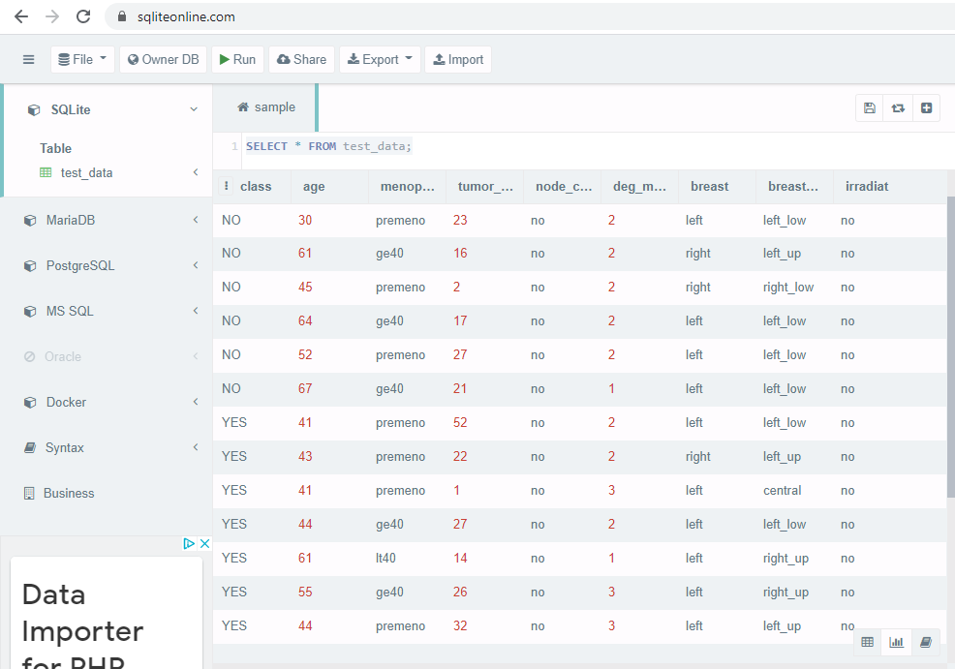

Select all rows where menopause column has the value “ge40”.

SELECT * FROM test_data WHERE menopause='ge40';

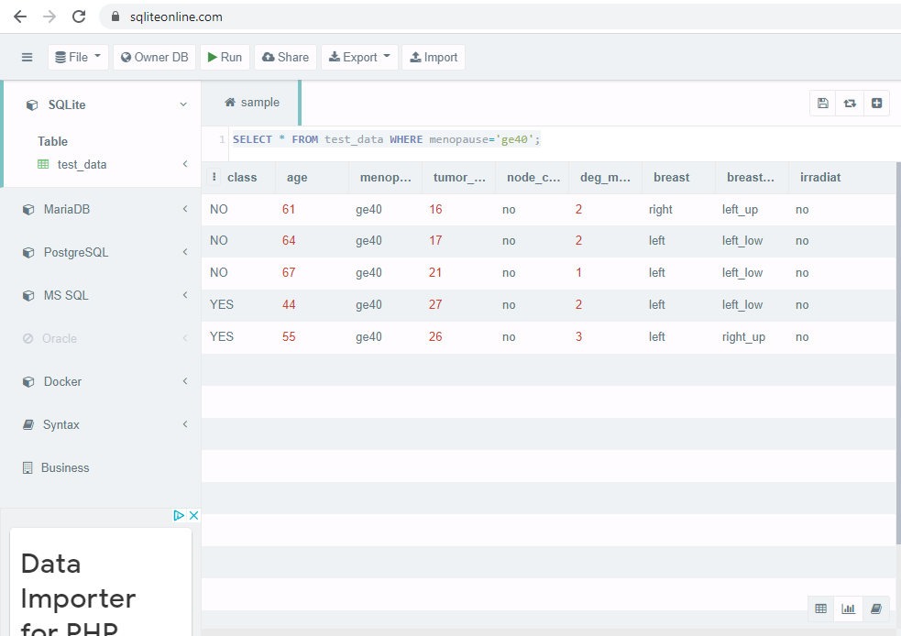

Select all rows where age is less than 41.

SELECT * FROM test_data WHERE age<41;

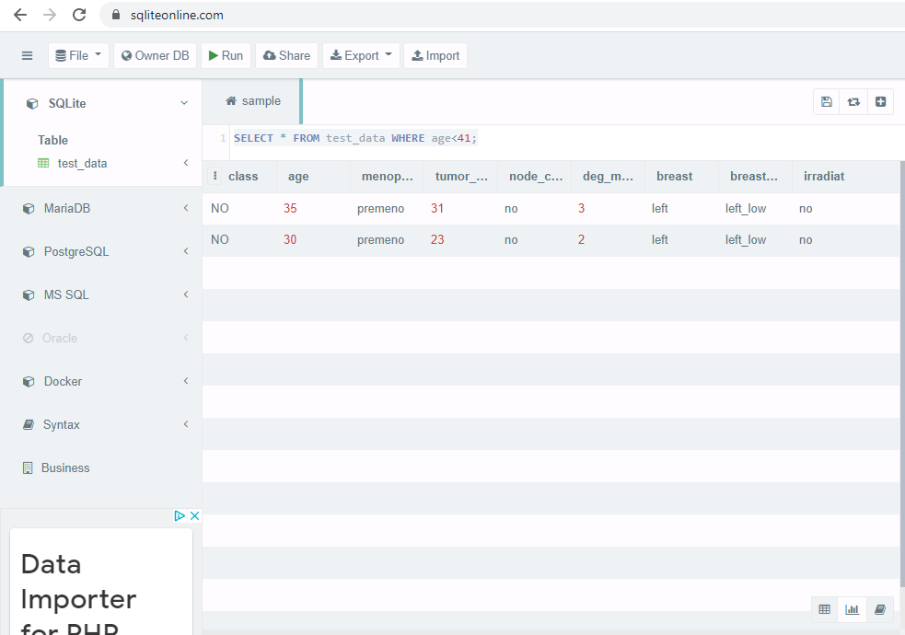

Select all rows where age is less than 41 and menopause column has the value “ge40”.

SELECT * FROM test_data WHERE age<41 AND menopause='ge40';

No data available that meets the criteria of the request
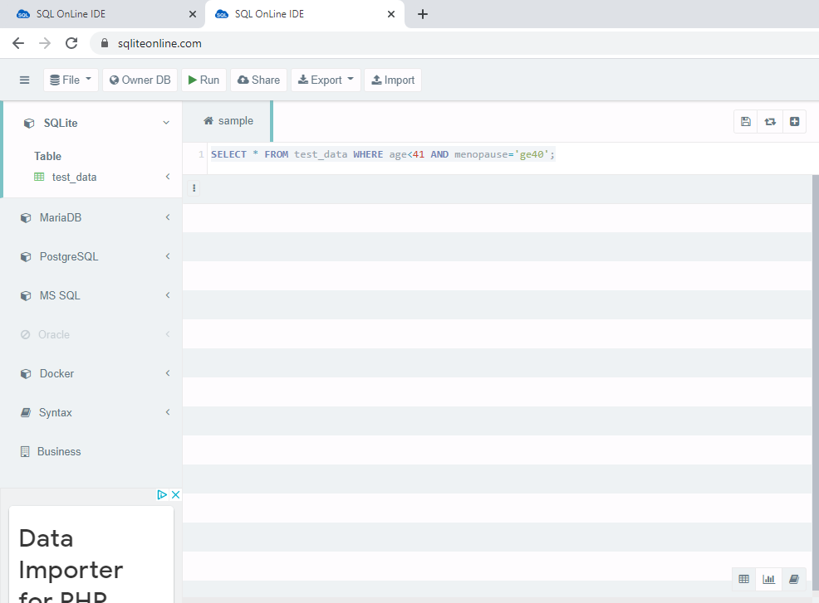

Compute the average age across all rows.

SELECT AVG(age) FROM test_data;

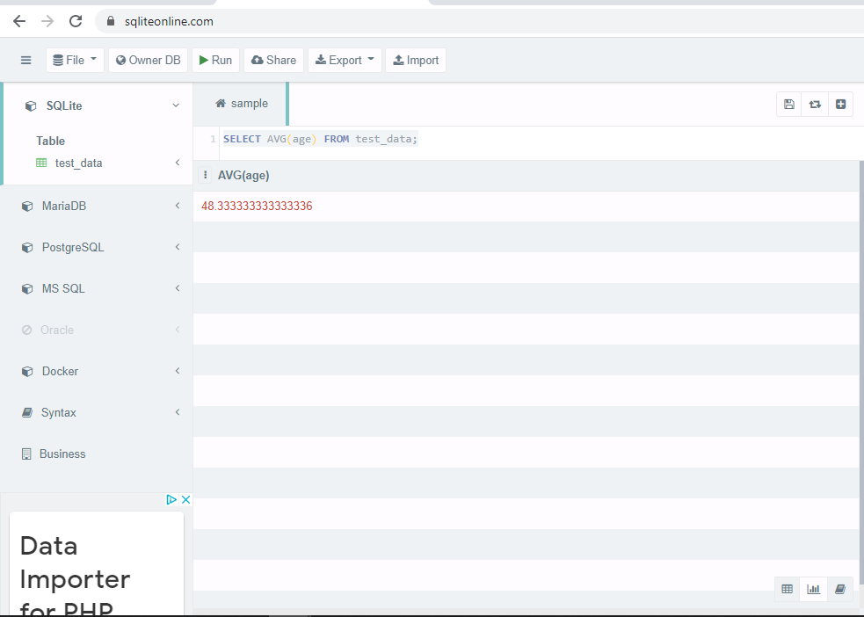

Compute average age across rows where deg_malig value is equal to 3.

SELECT AVG(age) FROM test_data where deg_malig=3;

